## How to get the list of students who graduated in summer 2024 and fall 2024 for both graduate and undergraduate CPTR/MATH students

Created by: Jane Stout, 2/27/25

1. Log in to Argos here: <https://evprod.csu.edu/>
2. Select Argos Web Viewer button

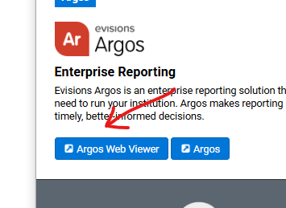

1. Navigate to **Student Lists**

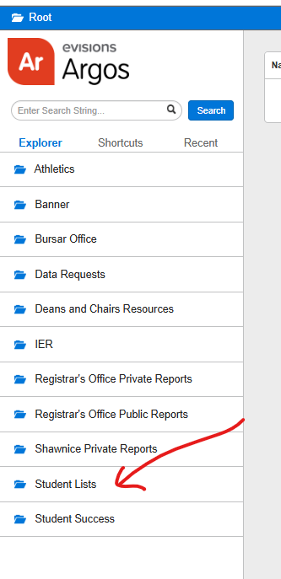

1. Navigate **to Degrees Earned by Major and Term** dashboard

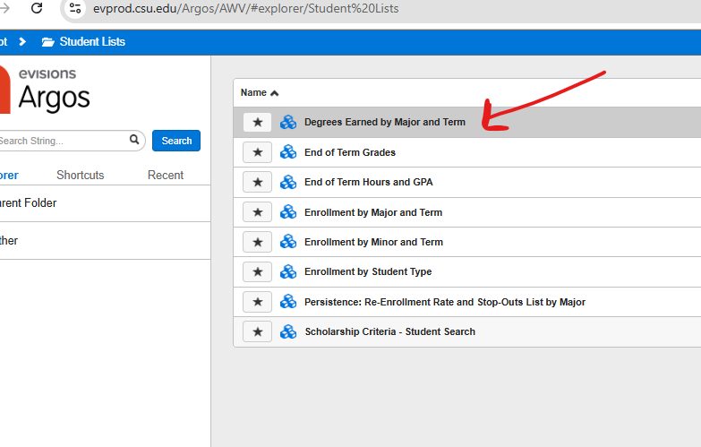

1. Work with the dashboard. Select the terms you wish to query, college, majors, and student level(s).

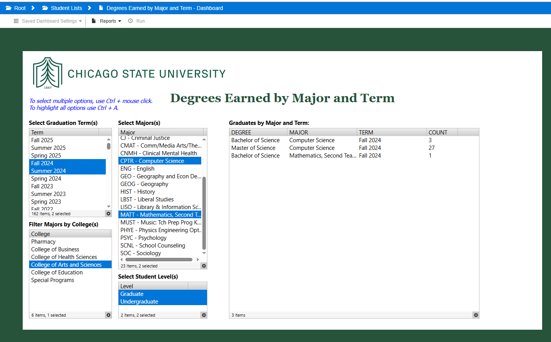

1. To export student list: click **Reports** button on toolbar. Click the **report name** that drops down.

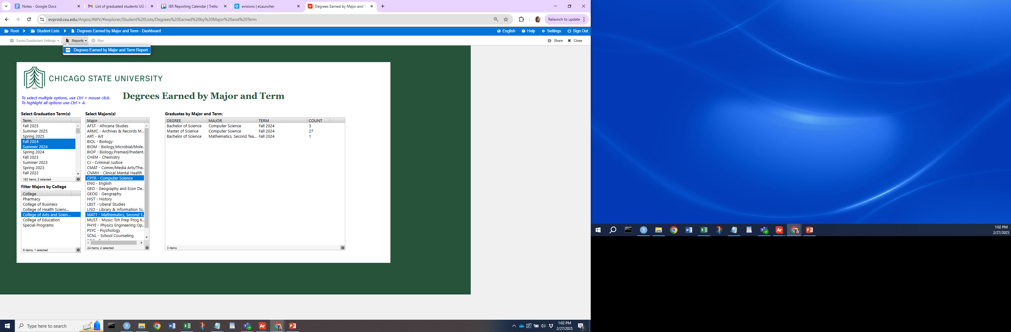

1. Click “**Run**” button on toolbar. Export and save your .csv file!

