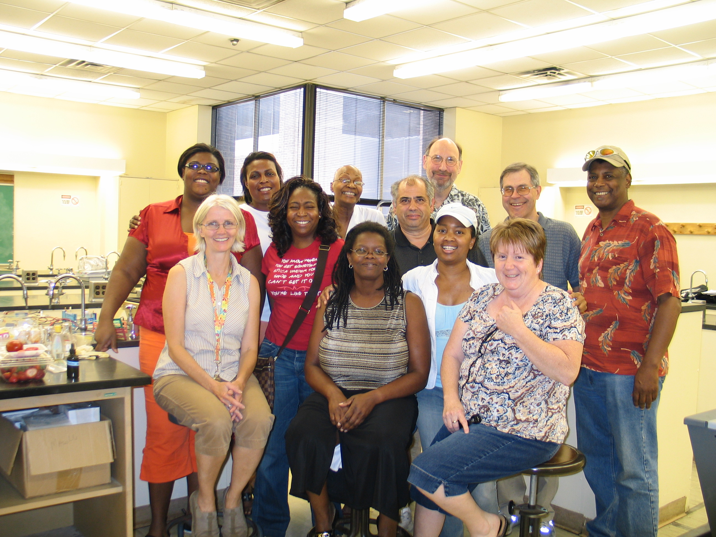

CSU Biology Van Summer Course Offered June 29th- July 10th.
Supported by a grant from the Illinois Board of Higher Education

Questions: email Charlie Ginsberg cginsber@csu.edu or Dr. Karel Jacobs (kjacobs@csu.edu)
You can also telephone Biology Main Office 773.995.2183

Course Description: The two week course aims to enhance the use of laboratory activities in high school biology classrooms (and other science courses such as environmental science.) Pre-service and in-service teachers are encouraged to take this course in order to improve their skills at conducting hands-on, inquiry-based laboratory activities and deepen their knowledge of Biology content including simple data analysis. Laboratories are selected for appropriateness and ease of use in the high school science classroom. Participants who complete the class are required to order laboratory equipment to be brought to their high school classrooms beginning Fall, 2010.

Course Date, Times and Location:
June 28th to July 10th, 9:30 AM to 4:00 PM at Chicago State University, Williams Science Center, Rooms: 215
Credit Hours, Stipend, Selection Criteria: 3 credit hours can be earned from CSU for the Fall, 2010 semester, but only if the Fall assignment is completed and presented at a required Fall workshop day. A stipend is offered for in-service teachers at a rate of $15 per hr or $ 900 for the two weeks. Tuition is waived for all participants. Pre-service teachers who will be student teaching in Fall 2010 or Spring 2011, may use this course to increase their total credit hours for the Fall, 2010 semester, if Fall, 2010 requirements are completed satisfactorily.
Eligibility. This course is open to Chicago Public School Secondary Science Teachers and CSU pre-service teachers in the undergraduate, non-degree or M.A.T. programs in secondary science. In-service teachers from schools not using the High School Transformation Curriculum will be given priority. Other teachers are encouraged to apply and applicants will be selected based on a first come first serve basis, until the course is full (15 participants.)

Please fill out the Application that follows and email it back to: cginsber@csu.edu or fax it to the Biology main office at 773.995-3759

